Postman API Testing
Daraz.pk
8
APIEndpoints—100%SuccessRate
AverageResponseTime:1.29s
Tester: M Hamza younas
Date: January 18, 2026

API Testing

Tester: M Hamza younas — Results: 8 endpoints tested, 100% success —
Performance: Avg 1.29s — Fastest: 422ms — Slowest: 2.61s
Endpoint | Metho | dDescription | Status | Time
/user | post | Register new user | 201  created | 1.07s
/orders/user/3 | Get | View order history | 200  OK | 580ms
/orders/1 | Get | Track order | 200  OK | 573ms
/cart/user/5 | GET | view user cart | 200  OK | 487ms
/carts/1 | Delete | Delete from cart | 200  OK | 448ms
/carts/1 | Put | Update cart | 200  OK | 422ms
/products/category/ | Get | Product by category | 200  OK | 2.61s
/products/1 | Get | search single product | 200  OK | 562ms
Table 1: API Test Results

API Execution Screenshots

The following screenshots provide visual evidence of successful API execution and response validation for all core backend endpoints.
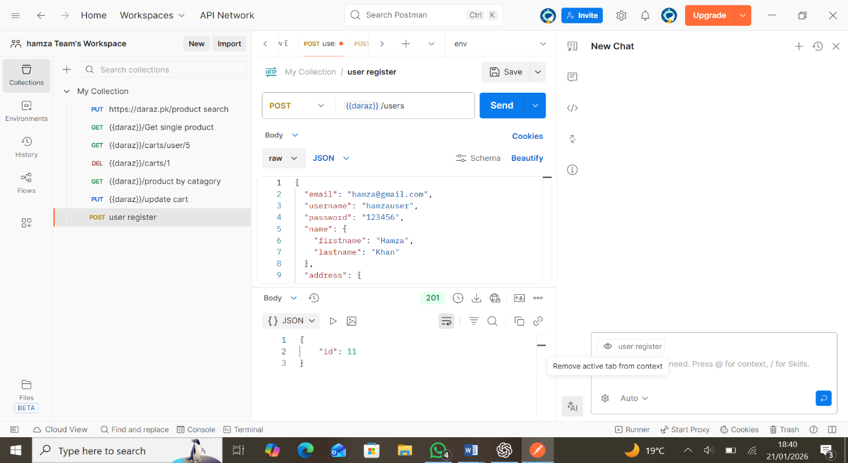
Figure 1: register new user (/user)
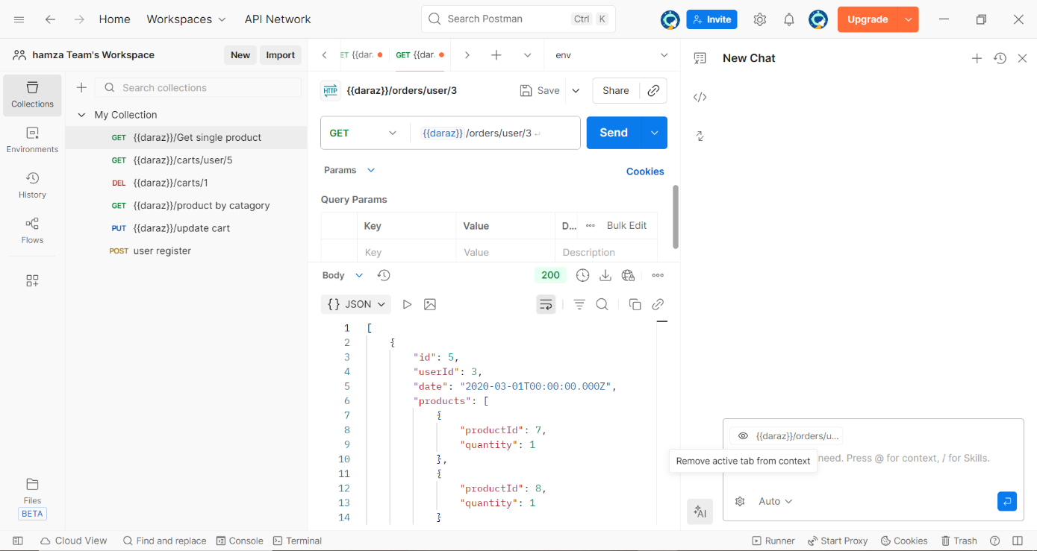
Figure 2: view order history (/orders/user/3)
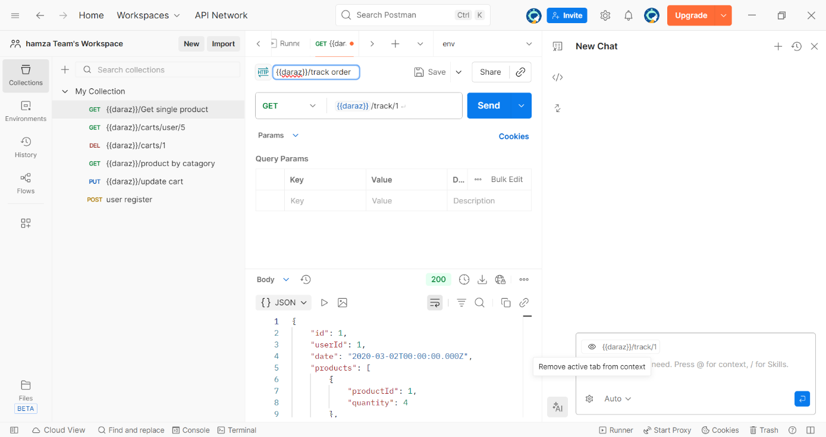

Figure 3: track order(/order/1)
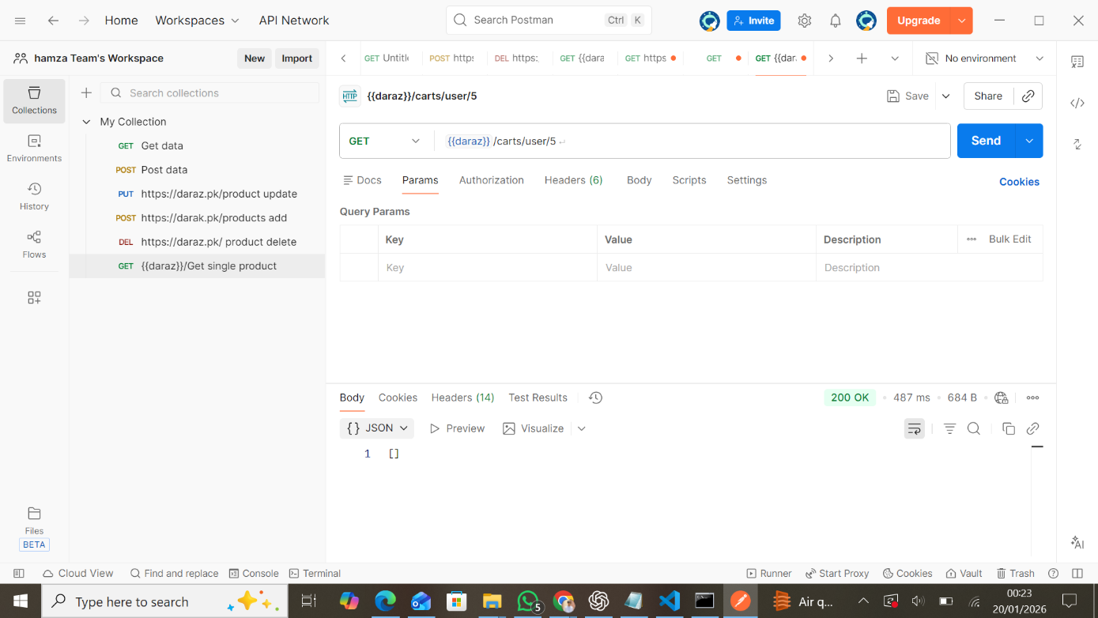

Figure 4: view user cart(/carts/users/5)
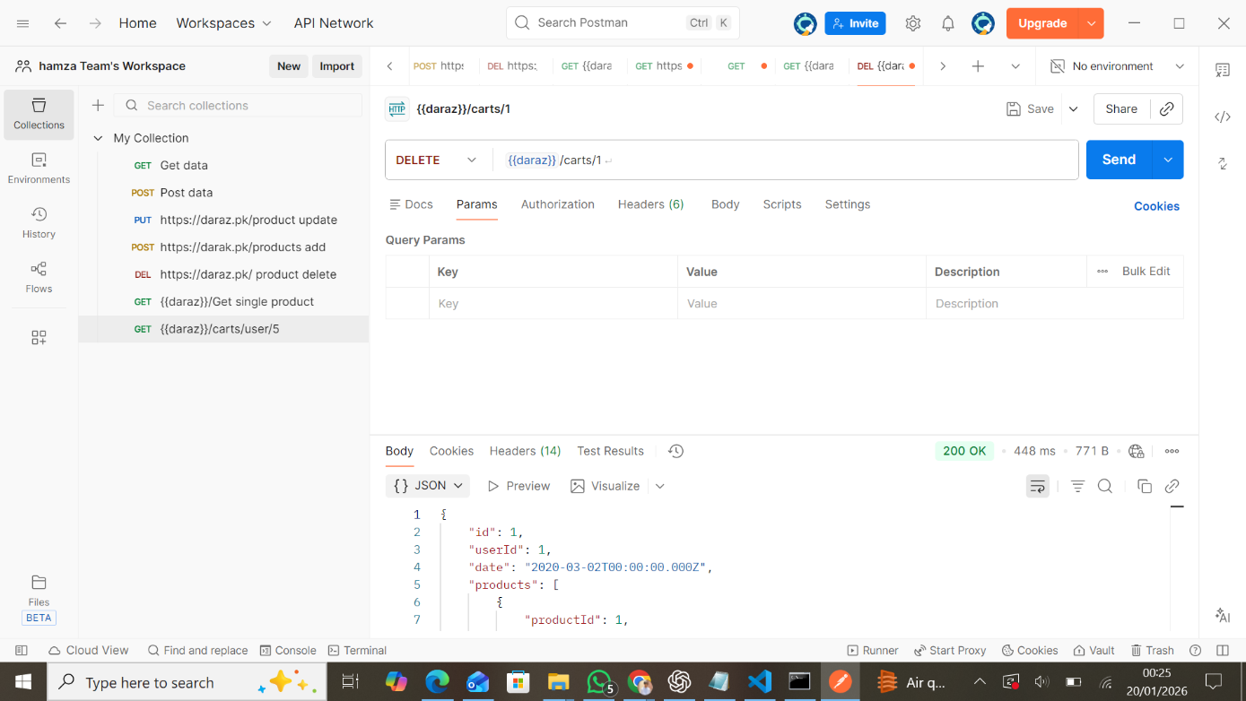
Figure 5: delete from cart (/delete carts/1)
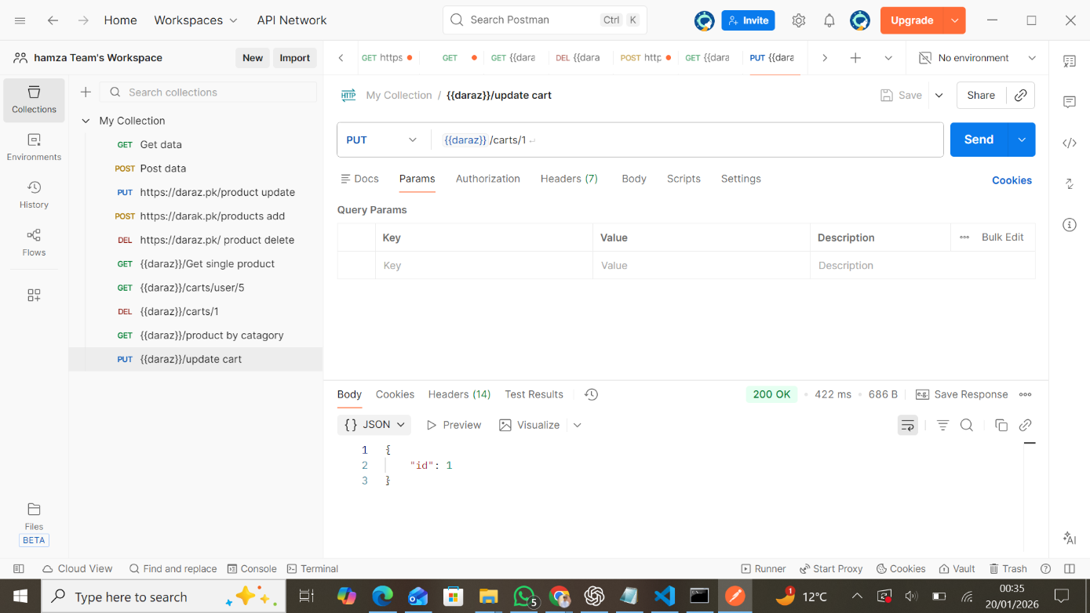

Figure 6: update/add cart(/carts/1)
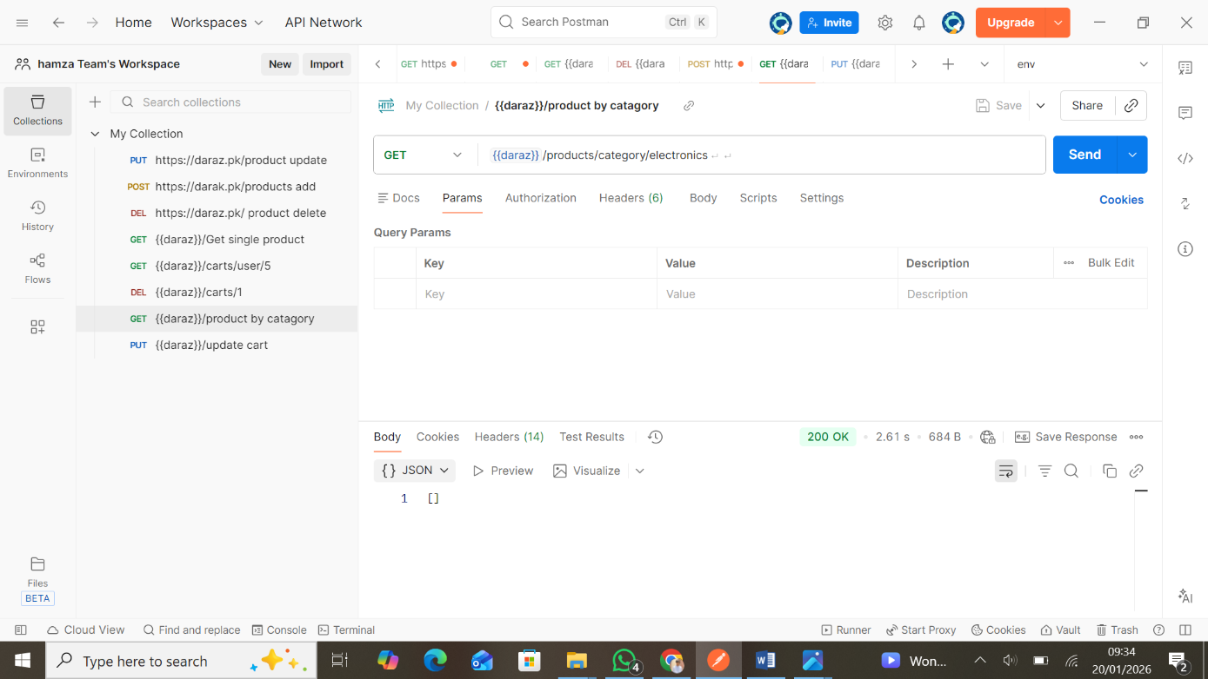
Figure 7: get/search product by category (products/category/electronics)
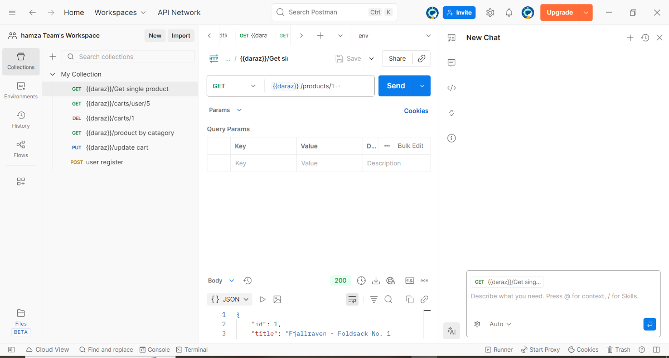
Figure 8: search single product (/products/1)

API Test Summary

Total Endpoints Tested: 8
Success Rate: 100%
Performance Metrics:
- Average Response Time: 1.27s
- Fastest Response: 422ms (/update cart)
- Slowest Response: 2.16s (/search product by category)
Status Codes: endpoints returned 200,201
All API endpoints have been thoroughly tested and validated for functionality, performance, and reliability.

